ASSIGNMENT-10.3
NAME:G.KARTHIK
ROLLNO:2403A510F8
BATCH:06

 |  |  |  |  | DEPARTMENT OF COMPUTER SCIENCE ENGINEERING
Program Name: B. Tech |  |  |  | Assignment Type: Lab |  |  | Academic Year:2025-2026
Course Coordinator Name |  |  |  | Venkataramana Veeramsetty
Instructor(s) Name |  |  |  | Dr. V. Venkataramana (Co-ordinator)  Dr. T. Sampath Kumar  Dr. Pramoda Patro  Dr. Brij Kishor Tiwari  Dr.J.Ravichander  Dr. Mohammand Ali Shaik  Dr. Anirodh Kumar  Mr. S.Naresh Kumar  Dr. RAJESH VELPULA  Mr. Kundhan Kumar  Ms. Ch.Rajitha  Mr. M Prakash  Mr. B.Raju  Intern 1 (Dharma teja)  Intern 2 (Sai Prasad)  Intern 3 (Sowmya)  NS_2 ( Mounika)
Course Code |  |  | 24CS002PC215 | Course Title |  | AI Assisted Coding
Year/Sem |  |  | II/I | Regulation |  | R24
Date and Day  of Assignment |  |  | Week5 - Thursday | Time(s)
Duration |  |  | 2 Hours | Applicable to  Batches
AssignmentNumber:10.4(Present assignment number)/24(Total number of assignments)
 | Q.No. | Question |  |  |  |  |  | Expected Time  to complete
 | 1 | Lab 10 – Code Review and Quality: Using AI to Improve Code Quality and Readability  Lab Objectives  - Use AI for automated code review and quality enhancement.  - Identify and fix syntax, logical, performance, and security issues in Python code.  - Improve readability and maintainability through structured refactoring and comments.  - Apply prompt engineering for targeted improvements.  - Evaluate AI-generated suggestions against PEP 8 standards and software engineering best practices  Task 1: Syntax and Error Detection  Task: Identify and fix syntax, indentation, and variable errors in the given script.  # buggy_code_task1.py  def add_numbers(a, b)  result = a + b  return reslt  print(add_numbers(10 20))  Expected Output:  - Corrected code with proper syntax (: after function, fixed variable name, corrected function call).  - AI should explain what was fixed.  Task 2: Logical and Performance Issue Review  Task: Optimize inefficient logic while keeping the result correct.  # buggy_code_task2.py  def find_duplicates(nums):  duplicates = []  for i in range(len(nums)):  for j in range(len(nums)):  if i != j and nums[i] == nums[j] and nums[i] not in duplicates:  duplicates.append(nums[i])  return duplicates  numbers = [1,2,3,2,4,5,1,6,1,2]  print(find_duplicates(numbers))  Expected Output:  - More efficient duplicate detection (e.g., using sets).  - AI should explain the optimization.  Task 3: Code Refactoring for Readability  Task: Refactor messy code into clean, PEP 8–compliant, well-structured code.  # buggy_code_task3.py  def c(n):  x=1  for i in range(1,n+1):  x=x*i  return x  print(c(5))  Expected Output:  Function renamed to calculate_factorial.  Proper indentation, variable naming, docstrings, and formatting.  AI should provide a more readable version.  Task 4: Security and Error Handling Enhancement  Task: Add security practices and exception handling to the code.  # buggy_code_task4.py  import sqlite3  def get_user_data(user_id):  conn = sqlite3.connect("users.db")  cursor = conn.cursor()  query = f"SELECT * FROM users WHERE id = {user_id};" # Potential SQL injection risk  cursor.execute(query)  result = cursor.fetchall()  conn.close()  return result  user_input = input("Enter user ID: ")  print(get_user_data(user_input))  Expected Output:  Safe query using parameterized SQL (? placeholders).  Try-except block for database errors.  Input validation before query execution.  Task 5: Automated Code Review Report Generation  Task: Generate a review report for this messy code.  # buggy_code_task5.py  def calc(x,y,z):  if z=="add":  return x+y  elif z=="sub": return x-y  elif z=="mul":  return x*y  elif z=="div":  return x/y  else: print("wrong")  print(calc(10,5,"add"))  print(calc(10,0,"div"))  Expected Output:  AI-generated review report should mention:  - Missing docstrings  - Inconsistent formatting (indentation, inline return)  - Missing error handling for division by zero  - Non-descriptive function/variable names  - Suggestions for readability and PEP 8 compliance |  |  |  |  |  | Week5 - Thursday

Task:1
Prompt::
Identify and fix syntax, indentation, and variable errors in the given script.
# buggy_code_task1.py
def add_numbers(a, b)
result = a + b
return reslt
print(add_numbers(10 20))
CODE
: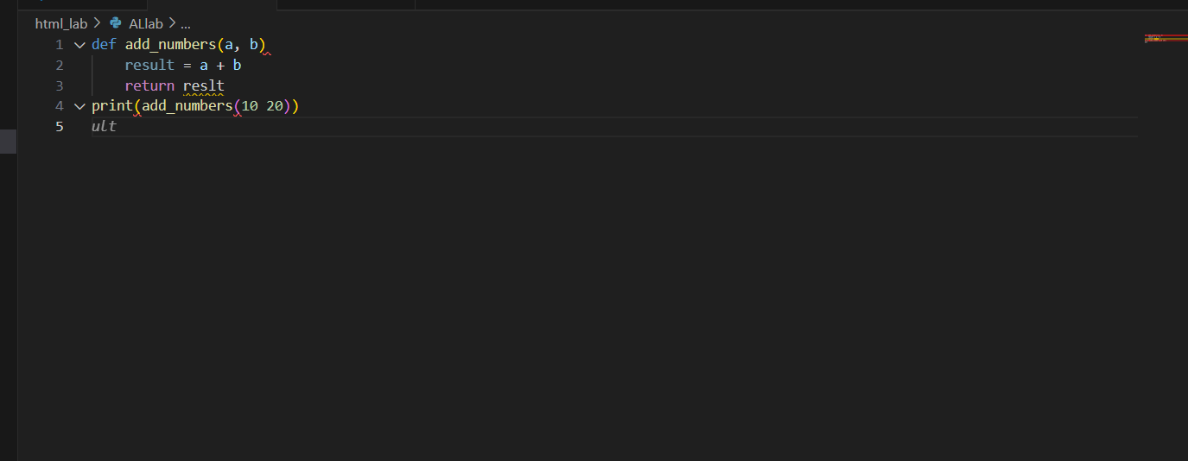
OUTPUT:
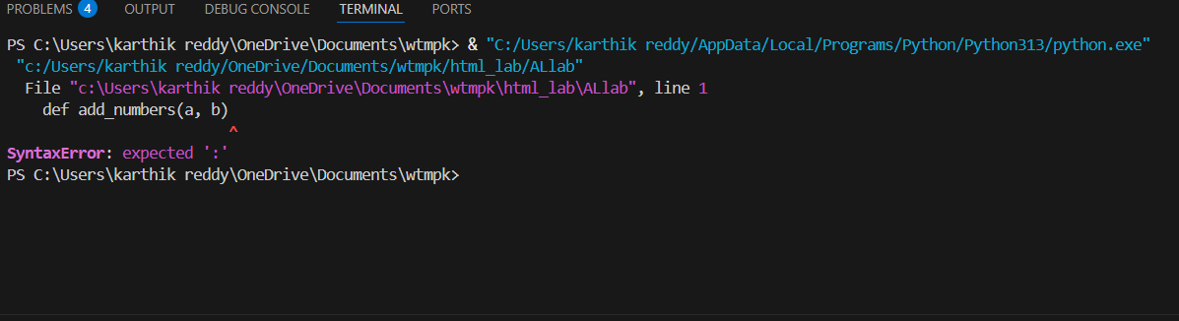

Observations :
Missing Colon (:) – Function definition def add_numbers(a, b) is incomplete without a colon.
Variable Name Error – The function returns reslt, which is misspelled and not defined
Function Call Error – In print(add_numbers(10 20)), a comma is missing between arguments.
Task:2
Prompt:
Optimize inefficient logic while keeping the result correct.
# buggy_code_task2.py
def find_duplicates(nums):
duplicates = []
for i in range(len(nums)):
for j in range(len(nums)):
if i != j and nums[i] == nums[j] and nums[i] not in duplicates:
duplicates.append(nums[i])
return duplicates
numbers = [1,2,3,2,4,5,1,6,1,2]
print(find_duplicates(numbers))

CODE:

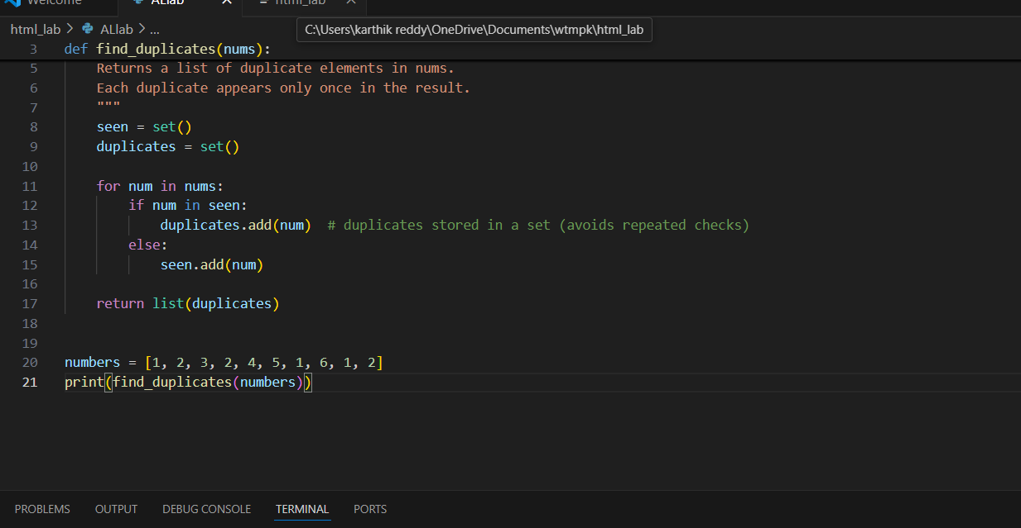

OUTPUT:
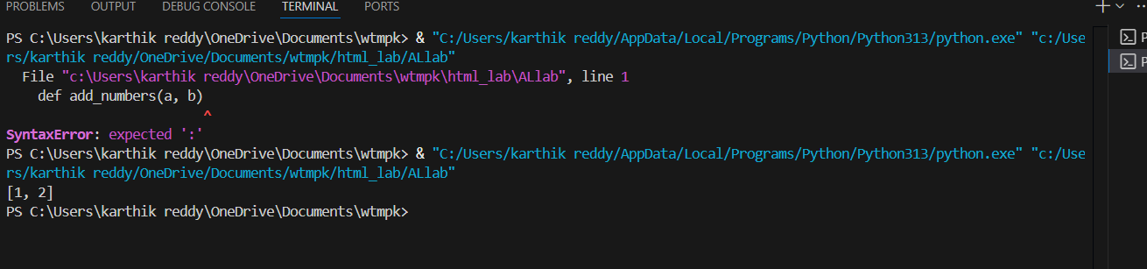

Observations
Inefficient Nested Loops
Uses two loops (O(n^2) complexity), making it very slow for large lists.
Redundant Checks
Compares each element with every other element, even after duplicates are already found.
Unnecessary Membership Test Inside Loop
nums[i] not in duplicates check inside the loop increases time cost.
TASK3:
Prompt:
Refactor messy code into clean, PEP 8–compliant, well-structured code.
# buggy_code_task3.py

def c(n):
x=1
for i in range(1,n+1):
x=x*i
return x
print(c(5))

CODE:
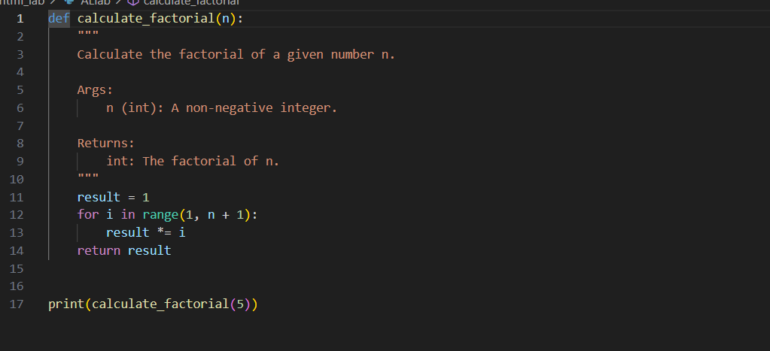

OUTPUT:

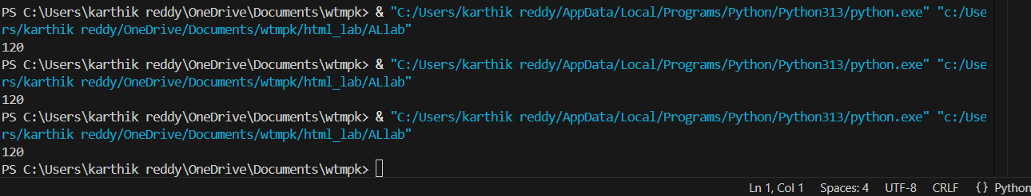

Observations:
Unclear Function Name
c is not descriptive; violates readability best practices.
Poor Variable Naming
x does not convey meaning; should be renamed to something like result.
Formatting/Indentation
Indentation is inconsistent; should follow PEP 8 (4 spaces).
Missing Docstring
No explanation of function purpose or parameters.
Readability
Overall style makes the code harder to understand and maintain.
Task4:
Prompt:
Add security practices and exception handling to the code.
# buggy_code_task4.py
import sqlite3
def get_user_data(user_id):
conn = sqlite3.connect("users.db")
cursor = conn.cursor()
query = f"SELECT * FROM users WHERE id = {user_id};" # Potential SQL injection risk
cursor.execute(query)
result = cursor.fetchall()
conn.close()
return result
CODE:
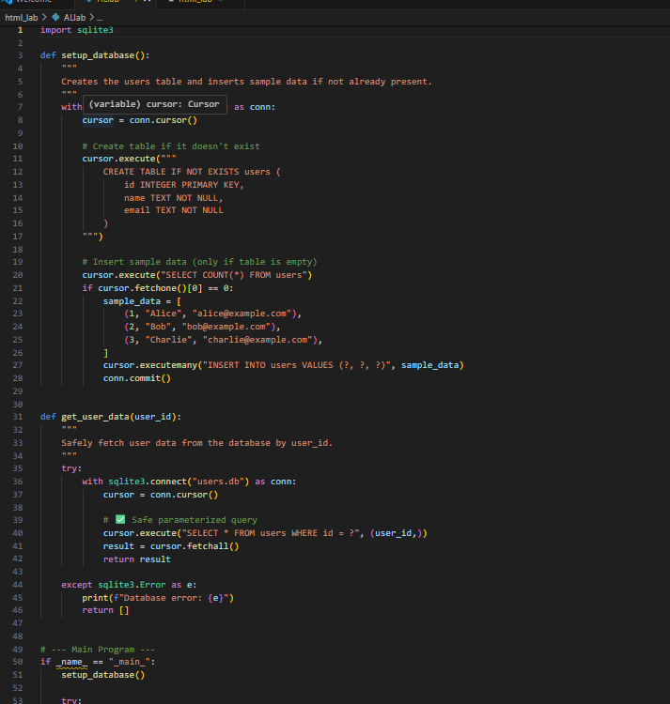

OUTPUT:
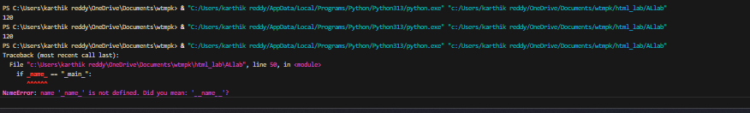

Observations:
SQL Injection Risk
Query uses string formatting (f"...") with user input → vulnerable to injection attacks.
No Input Validation
user_input is directly used in query without checking if it is an integer.
Lack of Exception Handling
No try-except block → program will crash if DB file is missing or query fails.
Resource Handling
Uses conn.close() manually → better to use with context manager for safer cleanup.
Task5:
Propmt:
Generate a review report for this messy code.
# buggy_code
def calc(x,y,z):
if z=="add":
return x+y
elif z=="sub": return x-y
elif z=="mul":
return x*y
elif z=="div":
return x/y
else: print("wrong")
print(calc(10,5,"add"))
print(calc(10,0,"div"))

CODE:
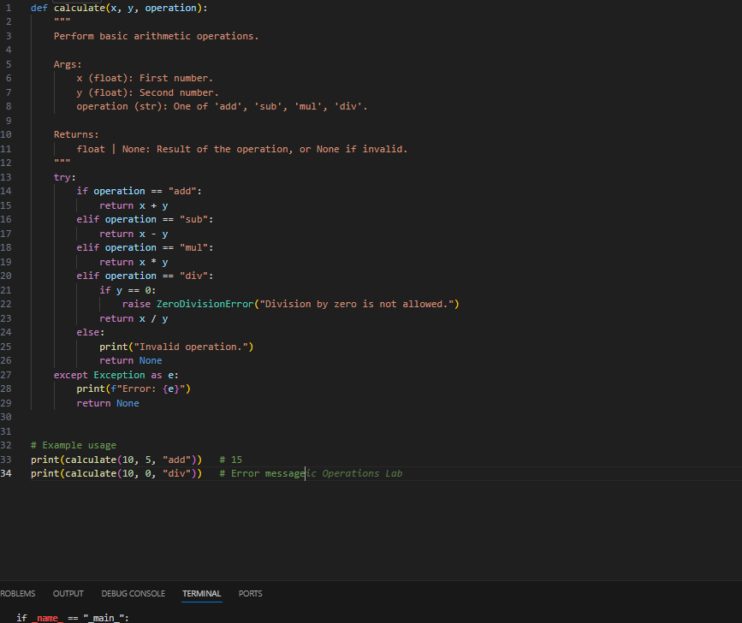
OUTPUT:
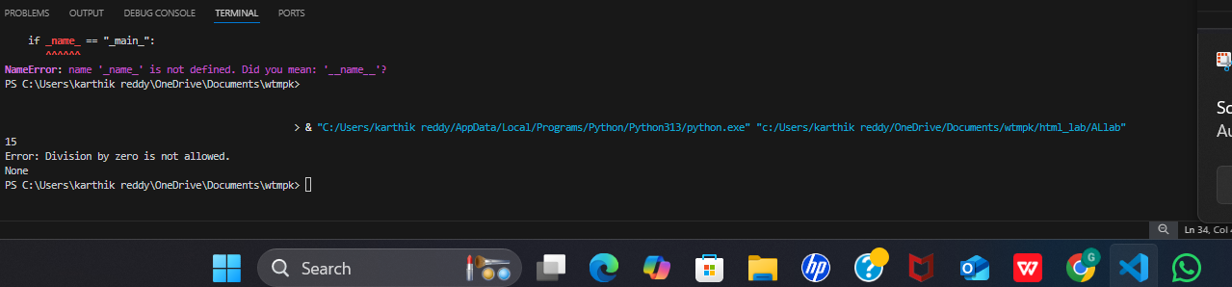

Observations :
Inconsistent Indentation & Formatting
Mixed inline and block statements → reduces readability.
Missing spaces after commas (x,y,z → should be x, y, z).
Unclear Function Name
calc is too generic; should be more descriptive like calculate.
No Error Handling for Division by Zero
print(calc(10,0,"div")) will raise ZeroDivisionError.
Poor Output for Invalid Operation
print("wrong") returns None instead of raising an error or returning a consistent message.
Lack of Documentation
No docstring or type hints explaining function usage.

